**Design Challenge:** Preventing Chronic Diseases through Behavior Change and Remote Monitoring

**Background:**

Chronic diseases, such as diabetes, obesity, cardiovascular diseases, and respiratory conditions, have become significant global health challenges. Prevention and effective management of these conditions are essential to improve patient outcomes and reduce healthcare costs. For this design challenge, you will be tasked with creating an innovative solution that addresses the following problem:

**Problem Statement:**

Design a solution that promotes the prevention and management of chronic diseases by focusing on behavior change, remote monitoring, and personalized interventions for individuals at risk or living with chronic conditions.

**Challenge Description:**

Chronic diseases are largely influenced by lifestyle factors, and early intervention and proactive management are crucial in preventing complications. Your task is to design a solution that empowers individuals to make positive behavior changes, enables remote monitoring of their health parameters, and provides personalized interventions to prevent the onset or progression of chronic diseases.

**Mandatory Deliverables**

* Concept Document (Introduction, Goals, Scope, Target Audience, Funtional requirements, Key Features, Assumptions (if any), Competitor Analysis, Design Process, User Testing/ Feedback Strategy)
* User Flow Diagram
* High-Fi Wireframes & Prototyping

**Optional Deliverables (Good to have)**

* User Personas
* Sketches/Low-Fi Designs

**Deadline:**09 June 2023 (Day End)

Please feel free to reach out me in case you have any questions. Good Luck 🙂

# **Problem Statement**

Create an innovative approach that encourages individuals at risk or already living with chronic diseases to adopt healthier behaviors, offers remote monitoring options, and provides personalized interventions to effectively prevent and manage their conditions.

**Introduction**

The purpose of this challenge is to provide a solution that caters the global health challenge of chronic diseases. This should focus on following factors:

* Behavior changes
* Remote monitoring of health parameters
* Personalized interventions.

This will improve the life style of the individual, providing better health care monitoring system, and offering personalized interventions. Aim is to prevent the onset or progression of chronic diseases and improve patient outcomes.

**Goals**

The goal for our solution is to:

* **Promote behavior changes**: To promote the individuals to maintain healthy behaviors to reduce the risks of chronic disease or to maintain the level of diseases (e.g. diabetes)
* **Enable remote monitoring:** Remote monitoring can be done by using some sort of data that can be added to some platform from the comfort of their home.
* **Personalized interventions**: Provide interventions based on individual’s specific health conditions, needs and goals.
* **Improve patient’s health conditions:** Enhance the health condition by pro
* **Reduce overall healthcare costs:** The solution will provide monitoring and control the health conditions and provide solutions. This will reduce the o

# **Scope**

Mobile and web application both will be made with same style interface. It will support behavior change, remote monitoring of patients, and personalized interventions. It will incorporate features that facilitate self-tracking, provide educational resources, offer goal setting and progress tracking, enable communication with healthcare professionals, and utilize advanced technologies for remote health monitoring. Also, by using the data that patient will provide we can predict what will be his health state. For example, if the person’s daily intake sugar is too much. This may alert them that in the upcoming months you can have diabetes. Also plan for chronic diseases will also be incorporated

# **Target Audience**

The target audience will be:

* The individuals who are at risks of developing such chronic diseases.
* The individual who are already living in these conditions.

The Age group is very broad from young adults to elderly, with varying level of technical proficiency.

# **Functional Requirements**

* **User Registration:** User can create his account and also provide relevant demographics and health history if any. User can also set goals initially.
* **Remote Health Parameter Monitoring:** enable users to track their health parameters such as, glucose level, weight, activity level, and medical adherence etc. considering the user is willing to do this.
* **Behavior Change Programs:** Offer different plans and programs to facilitate the user to perform better. For example, weight losing plan, stress management plan, monthly diet plan, and nutrition guidance etc.
* **Goal Setting and Progress tracking:** The health goals can be set by the user during registration and can be change if user wants. When health goals are set, user will get a plan accordingly and track their progress accordingly.
* **Education and Resources:** Provide different article and videos which is personalized only for specific users. This is possible because user set the goals and the contents will be shown to him/her accordingly.
* **Virtual Connection with Healthcare Professionals:** The user can message the professionals which is secure and also video consultation is also possible to offer guidance, discuss concerns and advices.
* **Reminders and Notifications:** user will get notifications on medical adherence, appointments, goals milestones and all the upcoming educational resources.
* **Integration with wearable devices (Optional):** The system can be integrated with popular smart watches or any wearable devices to track their health in real time.
* **Data Analytics and Insights:** The data that the user is providing will be analyzed and provide the user with action plan, recommendations and trends to track their health for future by sensing the patterns.
* **Privacy:** The data protection measurements should be catered and comply with the privacy standards to maintain confidentiality.

# **Key Features**

The features that application will have are following:

* Remotely heath monitoring of the user
* Personalized behavior change programs
* Educational contents and tools
* Goals setting and progress tracking
* Virtual connection to healthcare professionals
* Data analytics and insights
* Reminders and notifications for adherence
* Privacy and security integration

# **Assumptions**

* The users have smartphones or computers with internet connection
* Users are willing to provide medical history and their personal records
* Users are willing to improve health and want to prevent chronic diseases

# **Competitor analysis**

|  |  |  |  |  |
| --- | --- | --- | --- | --- |
| Features | Google Fit | Withings | My fitness Pal | Omada Health |
| Remotely health monitoring of the user | ✓ | ✓ | ✗ | ✓ |
| Personalized behavior change programs | ✓ | ✓ | ✓ | ✓ |
| Educational contents and tools | ✓ | ✗ | ✓ | ✓ |
| Goals setting and progress tracking | ✓ | ✓ | ✓ | ✓ |
| Virtual connection to healthcare professionals | ✗ | ✗ | ✗ | ✓ |
| Data analytics and insights | ✓ | ✓ | ✓ | ✓ |
| Reminders and notifications | ✓ | ✓ | ✓ | ✓ |
| Privacy and security integration | ✓ | ✓ | ✓ | ✓ |
| Integration with wearable devices | ✓ | ✓ | ✗ | ✓ |

**Note:**

✓ = Yes  

✓ = Moderate 

✗ = No

## **Google Fit**

Google fit have very robust tracking system with the integration with smart devices. But it lacks proper personalization when it comes to manage or prevention of chronic diseases. Google fit also not provide any sort of communication with health care professional. While it can be integrated with other applications too.

## **Screens**

**Home Page Journal Tab Browse Tab** 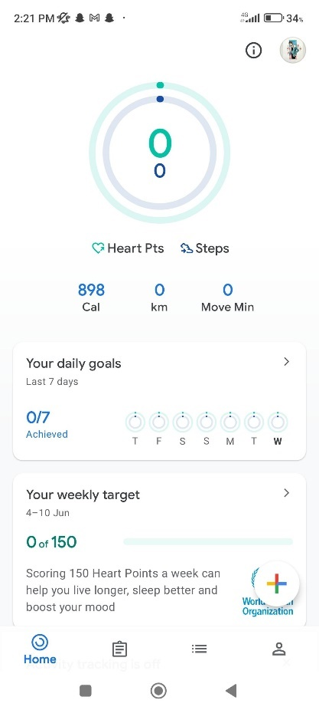 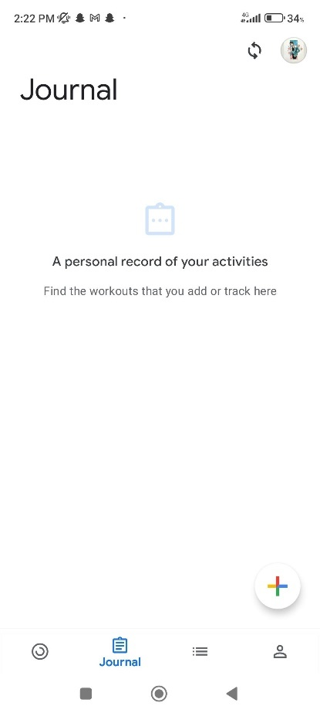 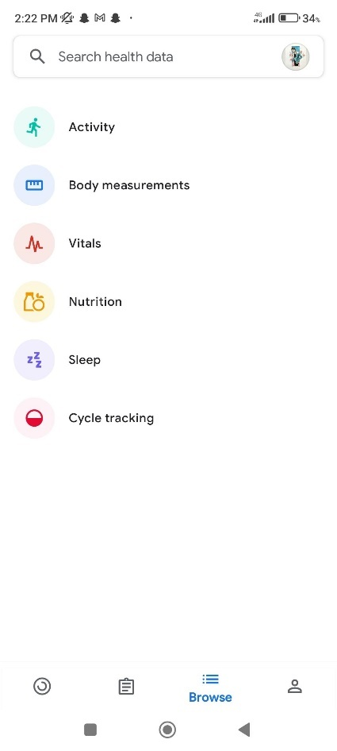

|  |  |  |
| --- | --- | --- |
| * Heart rates check * Targets * Activity Tracking * Trends * Links to some functionalities like sleep cycles, walking etc. | * The activity logs are listed here * Plus sign is for adding vitals in each tab | * It contains all the personal related data. * We can select each one and add the data or learn why it is nessecary |

**Profile Tab Vital Section**

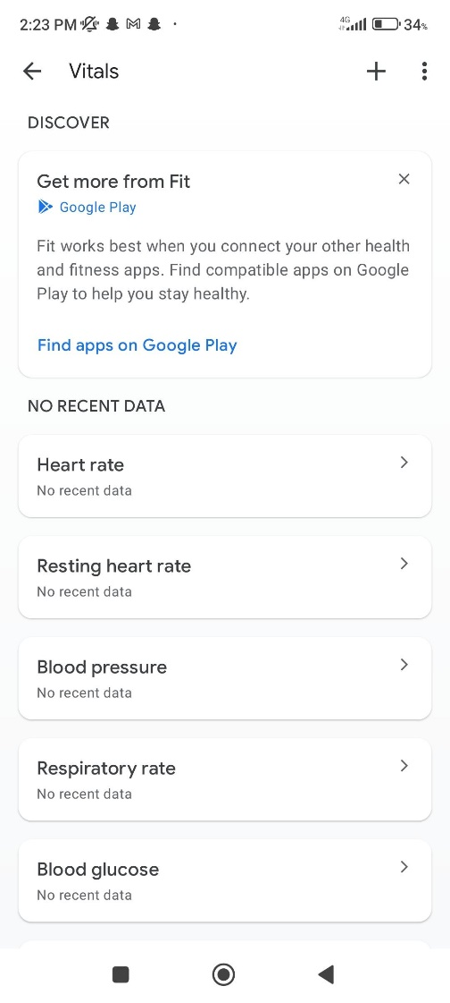 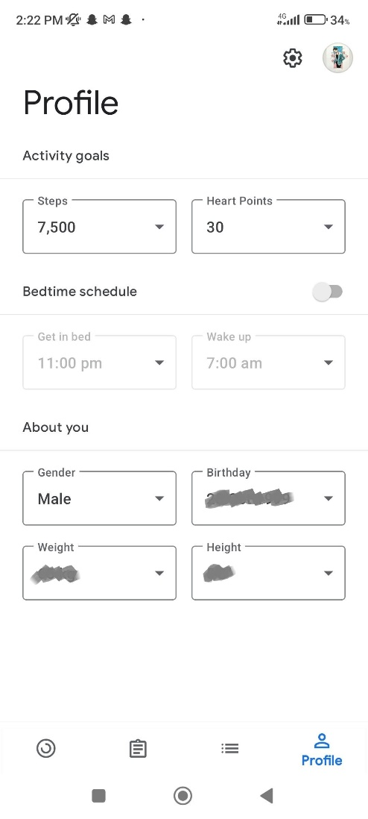

|  |  |
| --- | --- |
| * Opening any section in Browse tab will let user to add e.g., vitals | * Profile Tab contains personal information * Settings for Units, notification, display, account settings etc. |

## **Withings**

It is very similar to Google Fit application, but it does not provide any section to educate the user or to show them content related to their condition. It also the functionality to link with other application e.g using My Fitness Pal to adding daily food intake. But it has limited focus on chronic diseases and also lack direct communication with health care professionals.

## **Screens**

**Home Screen Measure Tab**

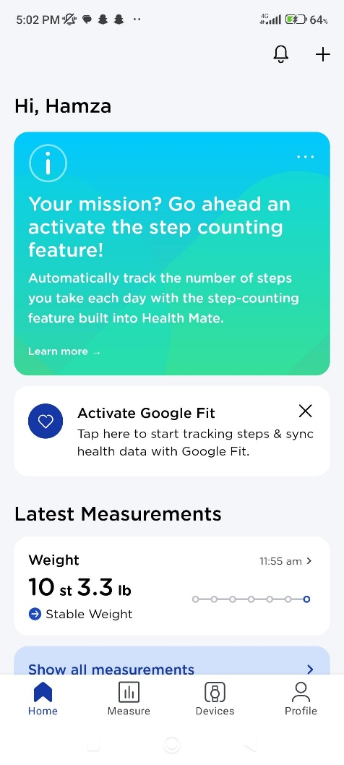 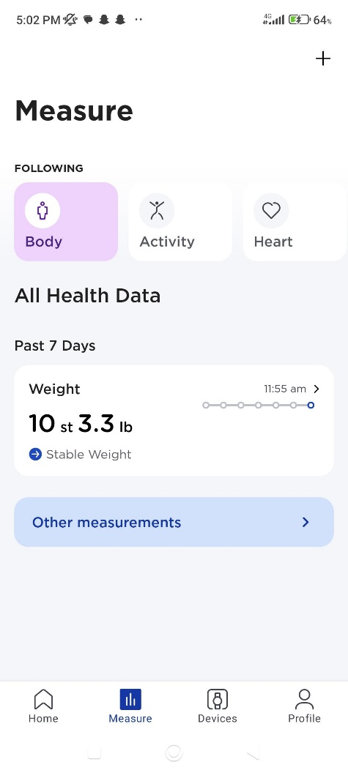

|  |  |
| --- | --- |
| * Missions are set by chatting with the bot available * This page shows latest trends and programs in which we are in | * This page shows data related to the vitals. * Weight and other measurements which is logging of food intake which in integrated with My Fitness Pal. |

Device Integration Tab Profile Tab

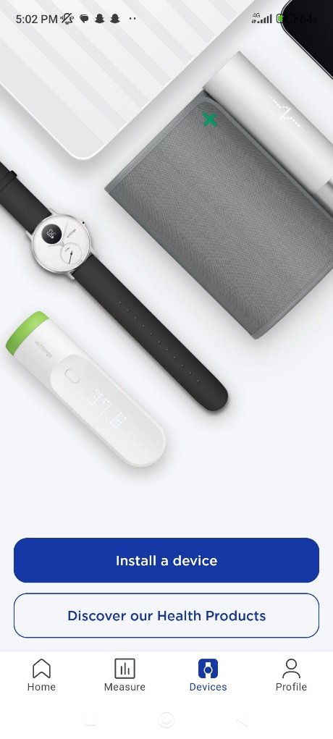 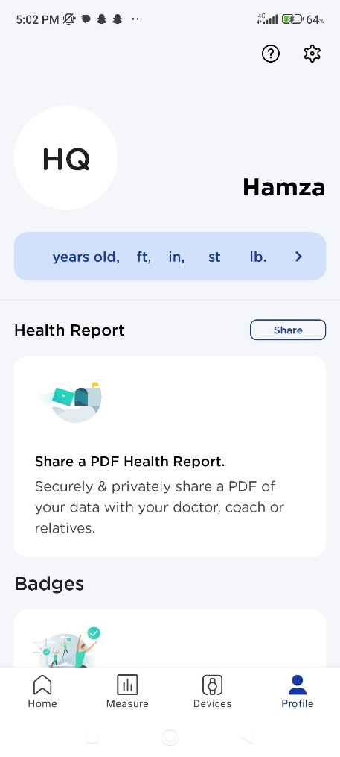

|  |  |
| --- | --- |
| * This tab helps the user to install different devices e.g. watches, sleep sensors, thermometers, trackers * There is also a link that lead to the website where we can find information about health products | * In profile tab, there is a button for asking question if user wants. * Settings tab * There is a system of badges which we can earn by achieving our goals. * We can have a report of our health in pdf format which can be shared * We can also add family member * There is mentioning of the application which withings supports in the form of logos |

# **MyFitnessPal**

MyFitnessPal has good tracking of food intake and activities. But this application has very limited focus on chronic diseases. This application has good feature of newsfeed, which is very unique. In this tab there are engaging videos and article for the user to look at. This will gain the interest of the user. But it has premium feature which is recently implemented. This made so many users to stop using the application. Because many features that are used in free mode are added in premium version. Also, one think that I like is tracking of food using bar codes.

## **Screens:**

**Dashboard Dairy Tab NewsFeed tab**

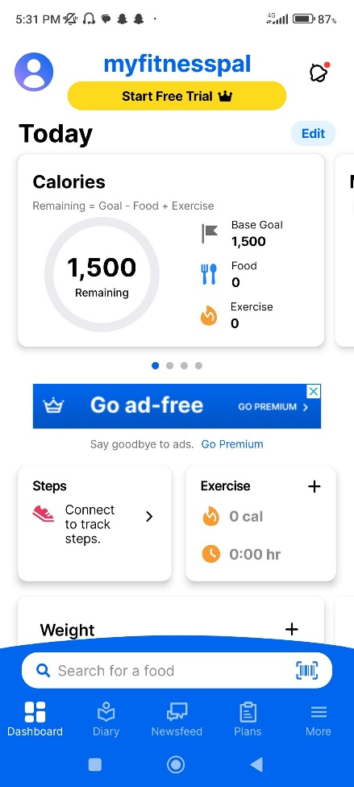 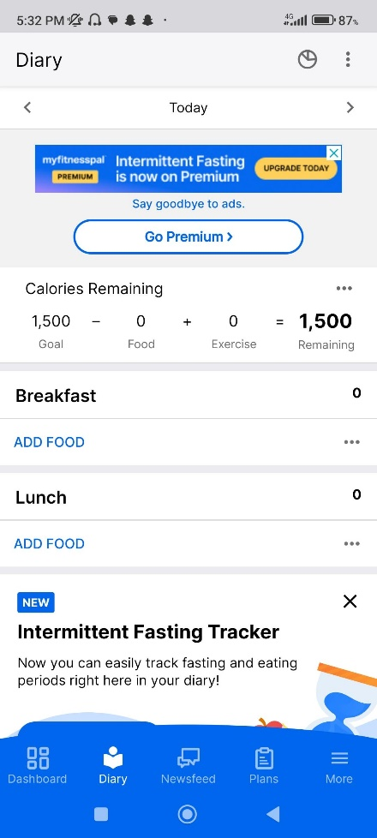 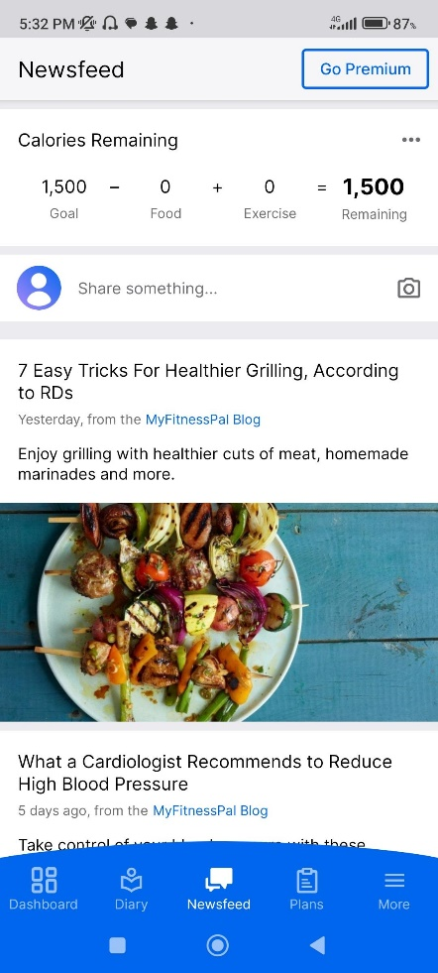

|  |  |  |
| --- | --- | --- |
| * Dashboard contains Steps, Exercise information, Daily Calories * Weight Tracking with days * We can also edit the tabs in dashboard which gives personalized customization | * This dairy tab contains day wise tracking of food intake. * Categorized food in the four type. * Water intake tracker * Nutrition option which shows a pie chart data day wise | * Contains articles, news, videos to engage the audience * We can also share our insight or upload a video showing e.g. how I plan my day. |

**Plans Tab More Tab (Personal)**

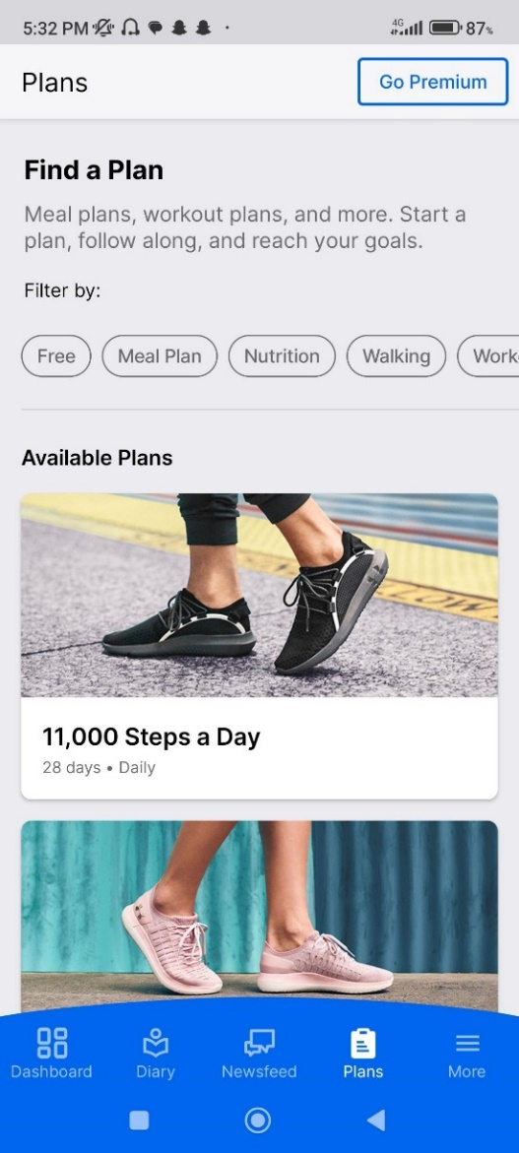 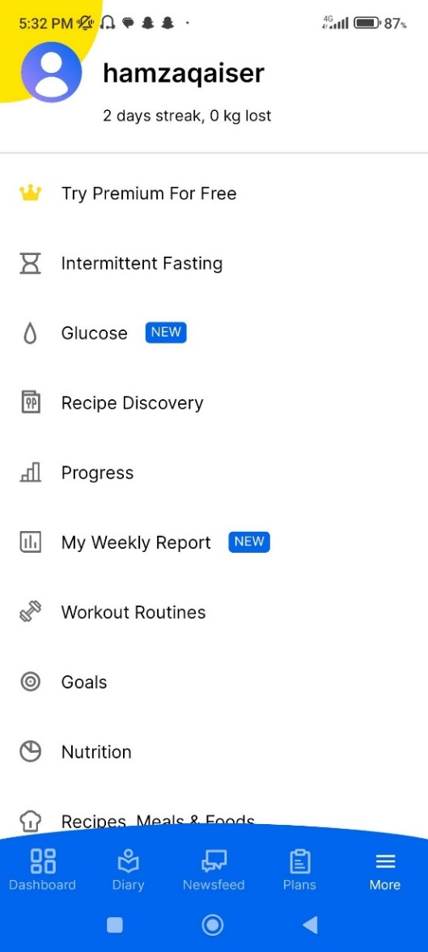

|  |  |
| --- | --- |
| * We can find plans from the list. But these plans can be paid or free. | * This tab contains personal information and setting related options |

## **Omada Health**

The features of this application are aligned to what we are going to achieve. Omada Health focuses on behavior change programs, remote monitoring, personalized coaching with health care professionals. There are educations lessons and resources options are also there. But this application is limited to area and service cost is high.

## **Screens:**

**Daily vitals Tracking Texting with professionals Meals Tracking**

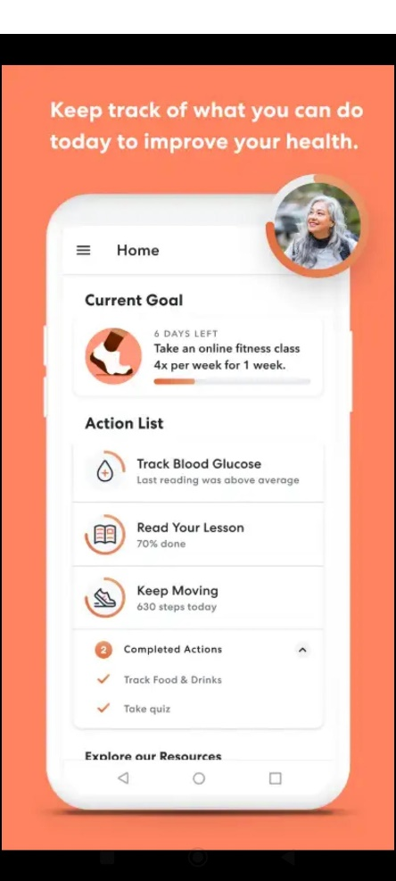 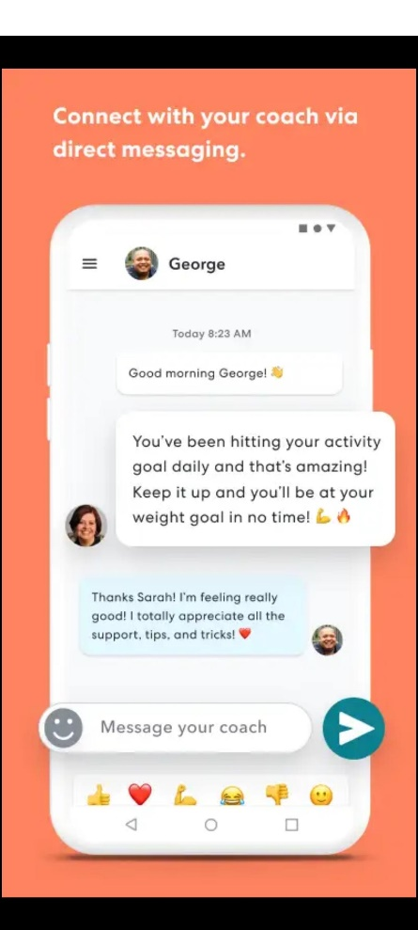 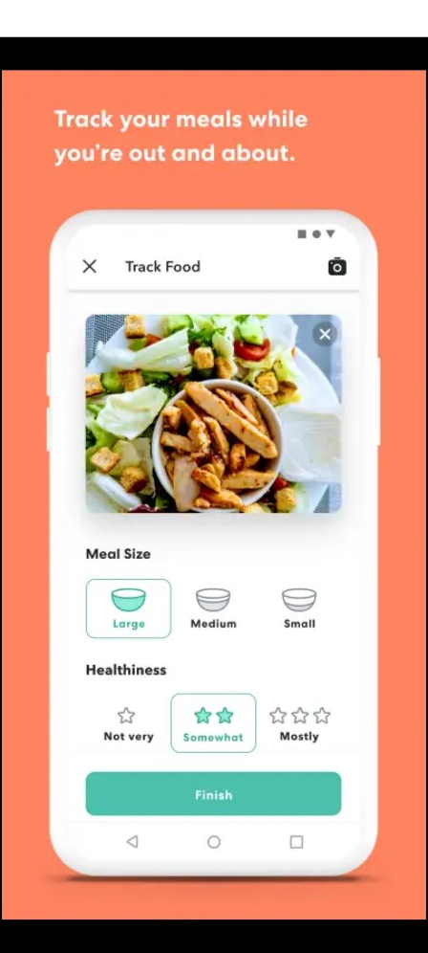

|  |  |  |
| --- | --- | --- |
| * Tracking of goals on daily bases makes by adding a loading type features to show the progress is good. | * Users can text to the avaiable professioanl and get advices. Healthy communication is a key. * Messages are protected and secure. | * Daily meals tracking and making quick buttons so that user cannot get frustrated by many actions. |

**Activity Tracking Goals Addition and Tracking Progress Mapping & Insights**

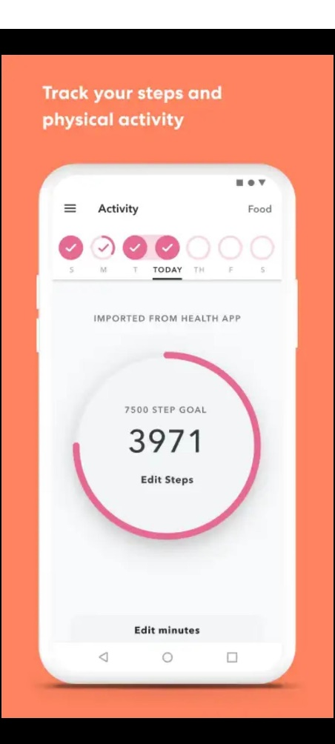 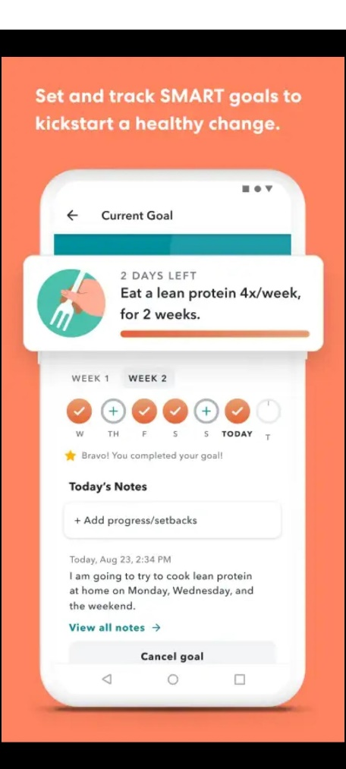 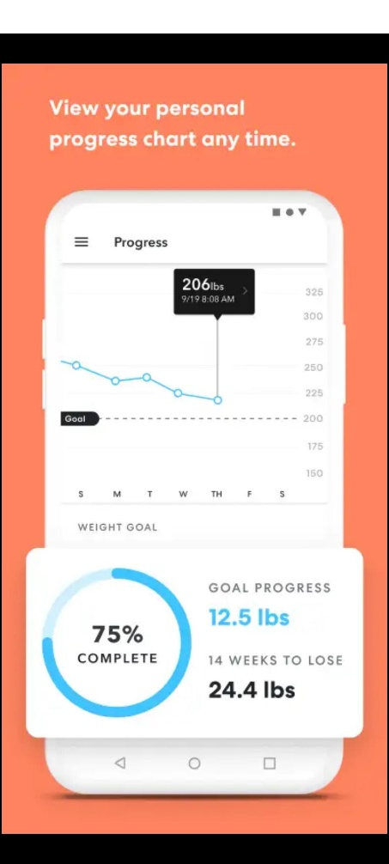

|  |  |  |
| --- | --- | --- |
| * Weekly activity streaks and steps trackers. | * We can set goals and track it on regular bases. * Add note and cancel goal if required. | * Progress mapping is done in the form of charts. * Showing trends and success flow to create positive impact on user. |

**Educational contents and Lessons**

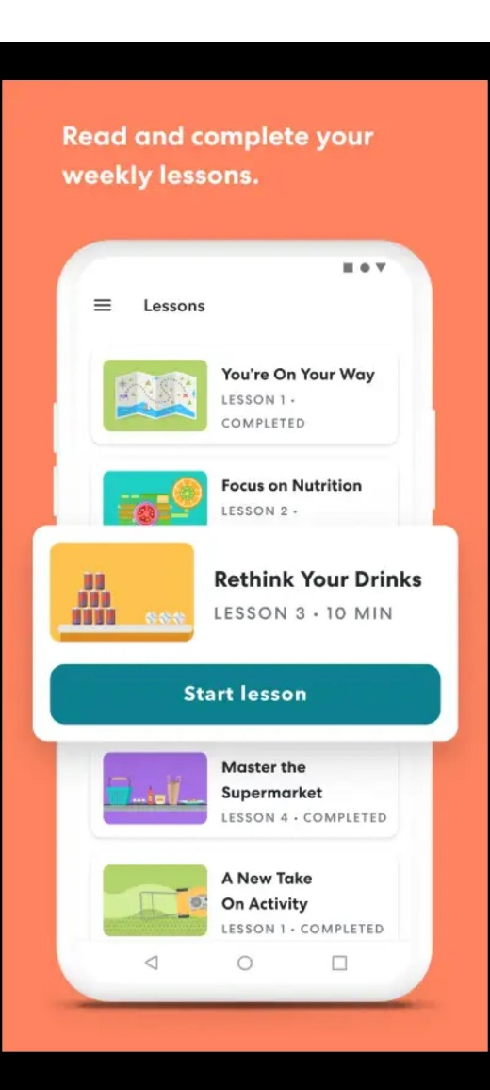

|  |
| --- |
| * Lessons section will give education regarding your goals. * We can start any lesson and learn about nutrition etc. |